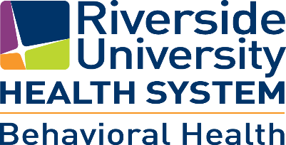

**Older Adults Integrated System of Care Meeting**

**February 11, 2025**

**Minutes**

**Chair:** Brenda Scott, Executive Director, NAMI Mt. San Jacinto

**Co-Chair:** Tony Ortego, Administrator, RUHS-BH Wellness and Recovery for Mature Adults Programs

1. Tony Ortego welcomed all in attendance and introductions were made.
2. The minutes of January 2025 were reviewed and accepted as written.
3. Tony Ortego read the OAISOC Vision/Mission Statement/Goals and Objectives.
4. Presentation by Christina Dominguez and Traci Cornelius – Office on Aging.
5. Regional Updates - Regional supervisors provided updates for each of their clinics. They discussed services that are provided at each clinic including in-person, telehealth, field based services and in-clinic therapy groups. All clinics follow strict protocols for the health and the safety of clients and staff. Staff recruitment updates were provided.
6. Public Comments/Suggestions/Questions
   1. None
7. Adjourn 1:54 pm