2017
Nelson, Sue, EdD
Division Director, Children Family and Community Services Santa Clara County Behavioral Health
4/12/2017
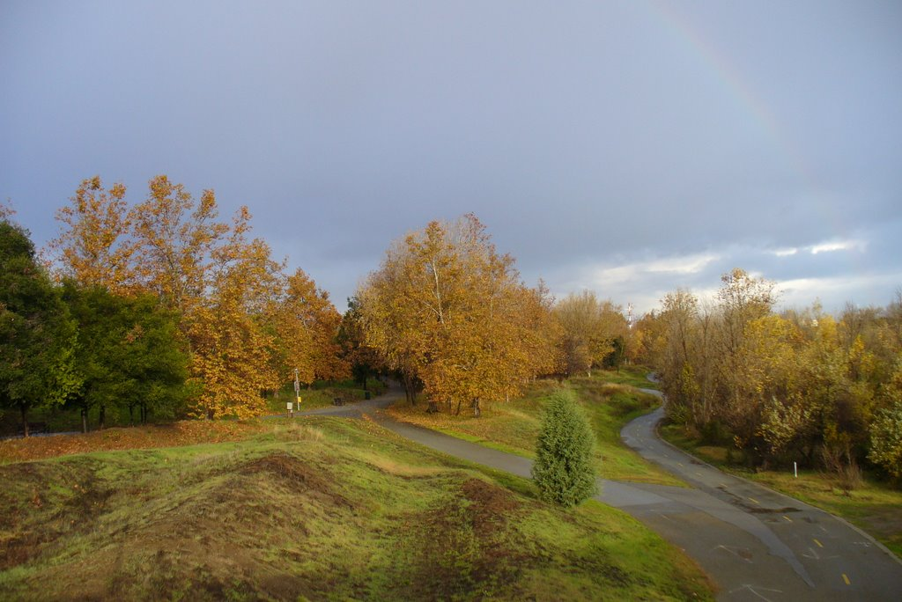
PROPOSITION 64: LOCAL JURISDICTIONS AND REGULATORY CONSIDERATIONS
PROPOSITION 64: LOCAL JURISDICTIONS AND REGULATORY CONSIDERATIONS
PROPOSITION 64
The Adult Use of Marijuana Act, known as AUMA, was passed in November 2016, and provides for the legal nonmedical use of marijuana, creates a regulatory system for nonmedical use, imposes taxes, and changes penalties for use. One cornerstone of AUMA is local control which allows jurisdictions to add and enforce more stringent guidelines, with a few exceptions, for growth, sales, production and use.
Ensuring healthy community environments, particularly for youth, is one of the roles and tasks of local government. Youth substance use, including marijuana, is driven by easy access and availability, as well as the social norms of the community. Research shows that regular use of marijuana in the teen years can have multiple impacts on youth and their future success:
- The teen brain continues to develop up until age 25.¹
- Regular use can result in the loss of up to 8 IQ points that lasts throughout adulthood.²
- Youth that use regularly are less likely to graduate from high school, start college, and are less likely to graduate from college than non-users.³
- One in 12 adults who uses marijuana will become addicted, whereas one in 6 teens who use marijuana will become addicted.⁴
- The younger someone begins to use marijuana, the more likely they are to become addicted.^{5,6}
- Marijuana use serves as a gateway drug and increases the risk for developing other substance use addictions.⁷
- Users are more likely to report thoughts of suicide and attempt and complete suicide, than non-users.⁸
- Compared to non-users, teens who used regularly experience increased rates of unemployment in adulthood.⁹
- Youth, and even young adult recreational users have abnormal changes in brain structure.^{10, 11, 12, 13}

Local jurisdictions have the ability to enact regulatory conditions that address the impacts of marijuana access and availability and the resulting normalization of use on their youth. Below are some issues local entities might consider as they contemplate the impact of local regulations on their youth.

INDOOR PERSONAL CULTIVATION
Jurisdictions can prohibit outdoor cultivation on a personal residence property, but they may not “completely prohibit” growing six marijuana plants inside a personal residence or in an accessory structure to a private residence. They can, however, “reasonably regulate” indoor personal cultivation. A personal residence is defined as a house, apartment unit, a mobile home or similar dwelling (AUMA, Section 4).
Local Control Indoor Grow Considerations:
- Cities and counties can require a permit and fee prior to cultivating up to six plants indoors.
- Jurisdictions can require written consent of the property owner prior to cultivation of marijuana within a residence or in a fully enclosed and secure structure on the property.
- Jurisdictions can limit extraction methods, which include a variety of volatile and non-volatile compounds.
- Jurisdictions can create regulations on how marijuana may be grown in residences such as restricting electricity and water use, establishing wattage limits (a typical plant can use 1000 watts of electricity) and other guidelines.
- Prior to the commencement of personal indoor marijuana cultivation entities may consider requiring adequate mechanical locking or electronic security systems be installed as part of the enclosed structure on a property or the area within the residence.
- Require that marijuana cultivation area(s), whether in a secure structure or inside a residence, shall not be accessible to persons under 21 years of age.
- To ensure that the indoor grow is for personal use only, local jurisdictions can specify that the authorized grower resides full time in the residence where the cultivation occurs and does not participate in marijuana cultivation in any other location in the town. This prohibits owners or renters of multiple dwellings from growing in more than one location.
- Cities may require that the plants be available for periodic inspection to determine if
- There are no more than six plants
- If a fire hazard exists because more electricity is being used than the residence is designed to handle
- If there is mold accumulation
- If water use is more excessive than needed to reasonably grow six plants
- If there is undue hazard for youth and children
- The residential structure continues to function at all times as a residence, with legal and functioning cooking, sleeping and sanitation facilities with proper ingress and egress. Rooms shall not be used for marijuana cultivation when such cultivation would prevent the primary use of rooms that are used for cooking of meals, sleeping and bathing.
- Require that the marijuana be kept on the premises and available for inspection by the Chief of Police or his/her designee.
RETAIL ISSUES
Local jurisdictions can regulate business license requirements, local zoning, and prohibit businesses, but not, as noted in Chapter 4, restrict grows inside personal residences. No licensee shall be located within a 600 foot radius of a school, day care center or youth center (AUMA, Section 6, Chapter 5).
Retail Considerations:
- Local jurisdictions can increase the radius around schools, day care centers of youth centers and can also add other “youth sensitive areas.” Should retail outlets have additional zoning restrictions? Should they be within 600 feet of colleges, churches, which often hold AA meetings, treatment facilities, apartment complexes or residences, or parks?
- What security staffing and other safeguards should retailers be required to provide?
- What hours should outlets be open?
- There are no restrictions on vending machines or mail orders.
- Local jurisdictions may consider requiring training for marijuana retailers on ID recognition strategies in order to prevent sales to minors.

ADVERTISING
“Any ads in broadcast, cable, radio, print and digital communications can only occur where at least 71.6 percent of the audience is reasonably expected to be 21 or older” (AUMA, Section 6, Chapter 15).
Advertising Considerations:
- Almost one-third of audiences can be under 21, and nothing prohibits advertising that targets young adults over 21. Do jurisdictions want to consider stronger limitations on advertising?
  - There are no restrictions on movie theaters. Ads could be shown with R-rated movies.
  - AUMA states that ads cannot occur on an Interstate or State Highway which crosses state borders. Jurisdictions may want to consider local restrictions for indoor or outdoor advertising for other roads.
  - Ads cannot occur “within 1,000 feet of a day care center, school for K-12, playground or youth center” (AUMA). Do jurisdictions want to permit ads near malls, stadiums, fairgrounds, colleges, treatment facilities, hospitals, churches, strip malls, in downtown areas, near parks or in other store windows?
  - Does the jurisdiction want to allow sponsorship of sporting and other events by marijuana-related businesses?

LOCAL DELIVERIES
A local jurisdiction cannot prevent transportation of products on its public roads, but can limit local deliveries. Delivery services must have a licensed brick and mortar location (AUMA, Section 6, Chapter 9).
Local Delivery Considerations:
- Local deliveries in a local jurisdiction can be provided by retailer located in another jurisdiction unless they are prohibited.
- If a jurisdiction allows deliveries, what are acceptable delivery hours?
- If allowed, should a business license be required for delivery services?
- Is there ID training for delivery personnel to ensure that ID cards are legitimate?
- Do Social Host Ordinances include providing marijuana for youth under age 21?
- Are Social Host Ordinances thorough enough to ensure that a delivery purchaser who is over age 21, may not share his/her purchase with individuals under age 21?

RESIDENTIAL AND COMMERICAL OUTDOOR CULTIVATION
Outdoor Cultivation Considerations:
Large site licenses will not be issued until January 1, 2023, for outdoor sites larger than one acre and indoor sites greater than 22,000 square feet (AUMA, Section 6, Chapter 6).
- AUMA limits Big Business involvement for five years. Nothing prohibits businesses from owning adjacent properties.
- Peak water diversion occurs during the summer months when water levels are at their lowest, impacting fish and wildlife.
- Jurisdictions can prohibit or restrict both outdoor residential and commercial cultivation.

EDIBLES
Dosage cannot exceed 10 mg of THC per serving, with servings scored or delineated. All marijuana or products shall be placed in re-sealable, child-resistant packaging that is not attractive to children. The label will contain the potency of THC and CBD as well as any solvents or pesticides or fertilizers used, and all ingredients in products (AUMA, Section 6, Chapter 13).
Edible Considerations:
- There is no limit on number of servings per item. For example, should a jurisdiction limit the number of servings in a gummy bear, a brownie, or other food items?
- Should we have a warning stamp if a package contains more than one serving? For example, should chocolate pieces, or a gummy bear that contains more than one serving, have separate warnings on each dose or serving?
- Jurisdictions may consider additional food safety regulations and require local health permits and with the option to inspect facilities.
- Should consumption of edibles be banned on public property?
- Should California consider developing a universal symbol for marijuana, similar to Oregon’s symbol?

PERSONAL USE
Smoking cannot occur within 1000 feet of a school, day care or youth center while children are present except on personal residence grounds if it cannot be detected while children are present (AUMA, Section 4).
Local Control Personal Use Considerations:
- Do we want to allow smoking on personal residence properties when the smoke can be detected within 1000 feet of retail outlets, stadiums, treatment facilities, churches, or near parks where youth may congregate?
- If smoking is banned in multiple unit dwellings, does the restriction include marijuana?
- Shall there be restrictions on smoking when the smoke can be detected on neighboring properties or residences?

ENVIRONMENTAL IMPACT ISSUES
Environmental Considerations:
- What are the potential impacts of pesticide and fertilizer use on water quality, wildlife, and water levels if a jurisdiction allows outdoor grows?
- Youth, young adult and adult rates have increased in Colorado. How will this impact our carbon footprint due to increased electricity usage?

REFERENCES

¹ Volkow, N., Baler, R., Compton, W., and Weiss, S. (2014). Adverse health effects of marijuana use. The New England Journal of Medicine, June 5, 2014, 2219-2227.
² Meier, M., Caspi, A., Ambler, A., Harrington, H., Houts, H., et.al. (2012). Persistent cannabis users show neuropsychological decline from childhood to midlife. Proceedings from the National Academy of Science, Oct 2, 2012, http://www.pnas.org/content/109/40/E2657.full.
³ National Institute on Drug Abuse. (2012). Research report series: Marijuana. NIH Publication 12-3859, p. 7. See also NIH, (2013). See also Marijuana facts for teens. NIH Pub. No. 13-4037, p. 5.
⁴ National Institute on Drug Abuse (2013). Marijuana Facts for Teens. NIH Pub. No. 13-4037, 5.
⁵ National Academies of Science (2017). The Health Effects of Cannabis and Cannabinoids, January 2017, 333.
⁶http://www.cde.state.co.us/sites/default/files/documents/dropoutprevention/resources/marijuanayouth_slidespdf121911.pdf.
⁷ National Academies of Science (2017), 357-373.
⁸ National Academies of Science (2017), 311-314.
⁹ National Academies of Science (2017), 280-281.
¹⁰ Gilman, J., Kuster, J., Lee, S., Lee, M., Kim, B, et al. (2014). Cannabis use is quantitatively associated with nucleus accumbens and amygdala abnormalities in young adult recreational users. The Journal of Neuroscience. April 16, 2014. 34 (16):5529-5538.
¹¹ Society for Neuroscience. (2014). Brain changes are associated with casual marijuana use in young adults. http://www.sfn.org/Press-Room/News-Release-Archives/2014 Brain-Changes-Are-Associated-with-Casual-Marijuana-Use-in-Young-Adults. April 15, 2014.
¹² Volkow, et al., (2014).
¹³Volkow, N., Wang G., Telang, F., Fowler, J., Alexoff, D., et.al. (2014). Decreased dopamine brain reactivity in marijuana abusers associated with negative emotionality. Laboratory of Neuroimaging, NIAAA. http://www.pnas.org/content/111/30/E3149.full.pdf

